DM ROOSEVELT VS. URBANDALE

Andrew Wade
Activities Director

Kathy Schmitt
Executive Secretary

Brandon Hope
Brent Wooters
Assistant AD

Ernst Brun
Sara Schwendinger
Jacob Kaemmer
Joel Miles
Tim Brown
Tayler Wineski
Ronnie Lewis
Joe Katich
Mike Groth
Steve Loew
Chris Harper
Matt Ream
Ried Bentley
Martha Chleborad
Daniel Pitz
Kristy Harken
Randy Wee
Christina Smith
Leah Watson
Antonia Mihalovich
Coaches

Rose Dino
Alexander Gray
Ellie Henson
Jennifer Luft
Micheal Davenport
Carly Triplett
Parker Klyn
Arts Directors

Thursday, September 19th, 2024

Event Information
Level: Freshman Football
Location: Randy Duncan Field at Roosevelt High School
Visiting Team Drop: Drop Off will be off Center Street, southside of Roosevelt.
Gates Open: 5:15PM for the TEAMS and 5:30PM for Spectators.
Start Time: 6PM
Uniforms: Home – Roosevelt (Dark) Away – Urbandale (Light)
Tickets: $7.00 for Adults and Students online or $8.00 Cash
Ticket Link: DM Roosevelt vs Urbandale 9th FB

Event Timeline for Game
PRE-GAME
5:15pm – Warm-Up
6:00pm – Kick-off (4) 12-minute quarters

EVENT MANAGEMENT – VISITING TEAM INFORMATION

TEAM BUS PARKING
Drop Off will be off Center Street, southside of Roosevelt.
Buses can park on Center Street as it is a one-way going west.

LOCKER ROOMS
No locker rooms are available at the field.

PRESS BOX
No press boxes are available. We do have a Hudl camera for recording.

WARM UP
Warm up is limited to game field only. Visiting teams will warm-up on the Southside of the field. Visitors bench is located on the east side of the field. Visiting fans will occupy the east side of the stadium.

SPECTATORS
Spectators will enter the NW and SW gate. Spectators can park off Center Street or Chamberlian parking lots. Tickets will be sold at the gate. Price is $7 with a credit card or $8 Cash.

SEATING
WE DON’T HAVE BLEACHES AT THE FIELD, SO SPECTATORS ARE TO BRING BAG CHAIRS, LAWN CHAIRS, OR STAND. SPECTATORS NEED TO STAY ON THE TRACK FOR SAEFTY OF THE SIDELINES. SPECTATORS CAN SIT OR STAND BEHIND EACH END ZONE, BUT 10 YARDS OFF THE BACK LINE.

CONCESSION STAND AND RESTROOMS
Concession Stand will be OPEN and restroom access will be located inside the school going through the SW gate.

Event Information
Level: Freshman Football
Location: Randy Duncan Field at Roosevelt High School
4419 Center Street
Des Moines, IA 50132
Start Time: 6:00PM
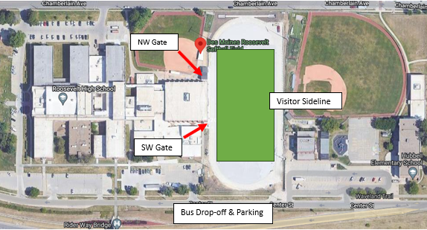
Officials Parking

Event Management – Personnel
Athletic Staff
Activities Director: Andrew Wade - 515-314-3134
Assistant AD: Brent Wooters
Assistant AD: Brandon Hope
Activities Assistant: Kathy Schmitt
Principal: Steve Schappaugh
Game Officials
Referee – John Parsons - parsonsproject17@gmail.com
Umpire – Cory Tigges - ctigges15@hotmail.com
Head Linesman – Chris Wilson - wilsoncj76@live.com
Line Judge – Patrick Owens - ptrkowens@hotmail.com
Back Judge – Ryan Owens - ryan.owens.2017@gmail.com

Athletic Trainer
Brian Sanders – Select Physical Therapy – briansanders@selectmedical.com
Site Workers
Gate: Kate Galligan – Southwest Gate (5:15PM-7:15PM)
Fatma Musharafa – Northwest Gate (5:15PM-7:15PM)
Field Prep: Andrew Wade/Brandon Hope
Score Board: Roosevelt Student Manager
Play Clock: No play clock, will be kept by the officials on the field.
Chains: TBD by Home Team
Concessions: Steve Loew

