
LeMLeMars
Urbandale vs. Sioux City North
Friday, September 27, 2024 @ 7:00 P.M.
Olsen Stadium
3200 Peters Avenue
Sioux City, Iowa 51106
Phone Number: 712-239-7000
Fax Number: 712-239-8270
Shawn Meth – Activities Director – 515-293-0578
Michelle Stevenson – Activities Secretary- 239-7000 ext. 3417

Officials: Scott Wilmont and crew
Tickets: All tickets are $7 and can be purchased online before the event through BOUND. Ticket Gates are located on the East, West and North sides of the stadium. Please inform your fans that we are cashless at our gates. Fans should either purchase tickets prior using the link or you can give them access to the QR CODE below.

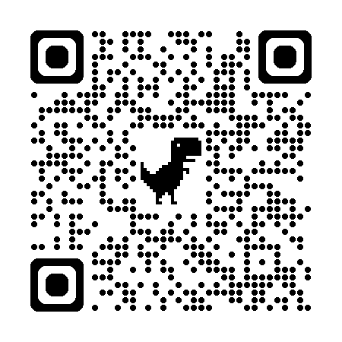

Jerseys: North High will wear Dark Jerseys

Football: Wilson GST (National Federation Approved)

Parking and dressing rooms: The visiting team will unload in the west parking lot behind the scoreboard. Fans can park in the East or West parking lots at the stadium. There is also street parking available. (not on Peters Avenue). SC North will use the upper locker room and the visiting team will use the lower-level locker room.

Press Box: There is sufficient room on the upper level of the press box for coaches and/or videotaping. Attached is a plan of the Press Box for coaches.

Pre-Game Schedule:
5:30 p.m. – Gates open
5:30 p.m. – Dance warm-up
5:35 p.m. – Marching band warm-up
5:55 p.m. – Marching Band off the field
5:55 p.m. – Teams on the field for warm-up
6:45 p.m. – Teams leave the field and head to the locker room
6:55 p.m. – National Anthem
6:58 p.m. – Teams return – player introductions – coin toss
7:00 p.m. – Kickoff

Halftime: We will run a 15-minute halftime. The referee will start the clock when both teams have cleared the field. Our band will be on the field for a minimum of 10 minutes. As soon as the 15 minutes runs down, an additional 3 minutes will be added for the mandatory warm-up period.


Olsen Stadium
Press Box Assignments
West End of the Field East End of the Field
Top Level
North
Coaching Staff

(Upper Level)

North
Coaching Staff

North
Video/Stat Crews

Visiting Team Radio
Visiting
Video
Crew

(Upper Level)

Overflow Press & Radio

(Lower Level)

Press – Sioux City
Clock and Message Board
Public Address

(Lower Level)
B
Bleachers
Visiting Coaching Staff

